Using the messenger feature in Infinite Campus
September 16, 2016
With the last update came a change in the messenger. Use this cheat sheet to get you started.
STEP 1
Sign into IC and go to Campus Instruction. The screen should default to the Message Center.
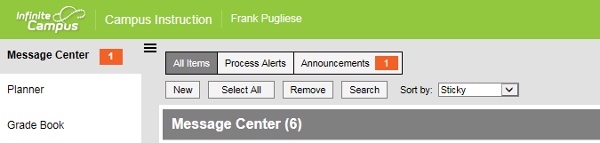
STEP 2
Click on new and the screen below will appear.
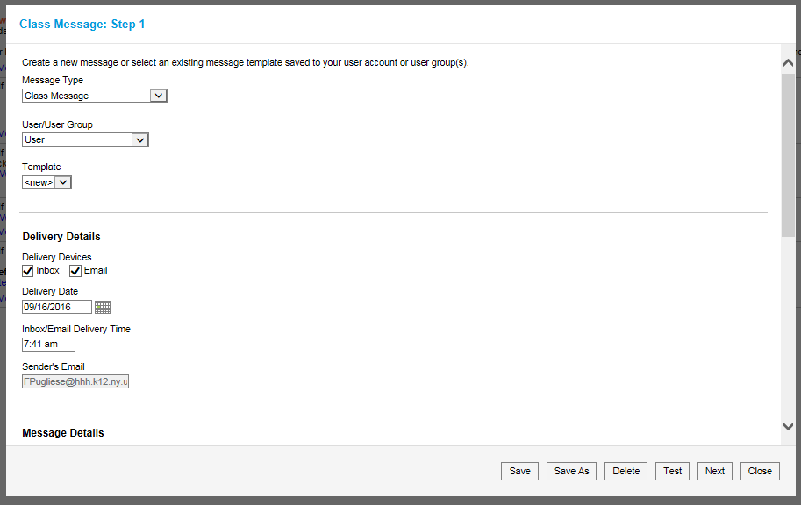
From this screen you will begin the process of either selecting a preexisting message or creating a new one.
Message Type is self-explanatory, select the type of message being sent
User/User group leave the default “user” selected
Leave “new” selected from the template menu for a new message
Select the template you’d like to use if sending a previously created message
Step 3 (If creating a new message)
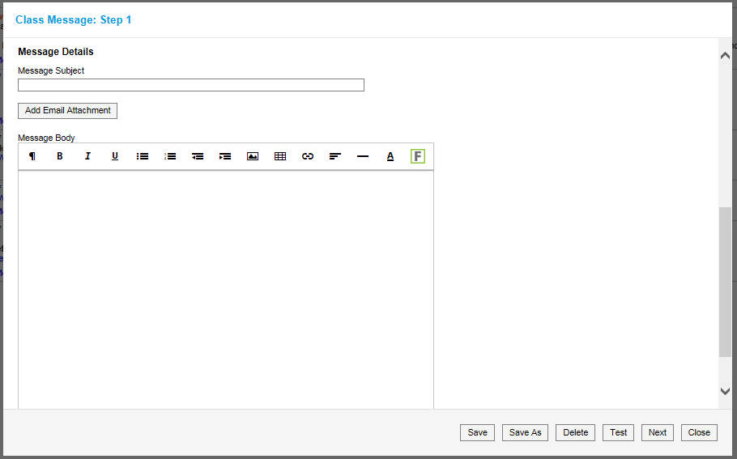
Enter the name of the message in the subject box
Create you message
Add any attachments
Select Save (enter a name for your message)
Then hit next to select the recipients

Step 3 (If using an existing message template)
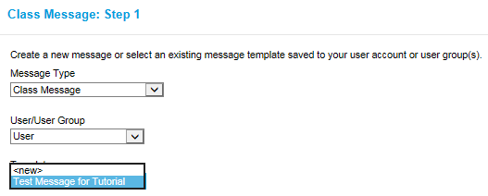
Select the message you’d like to send and then hit next at the bottom of the page.
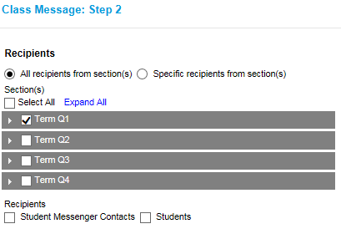
On this screen you get to select the classes and/or recipients
Checking specific recipients allows you to narrow your message distribution
All recipients is everyone in that section (Select all is going to give you every student on every roster)
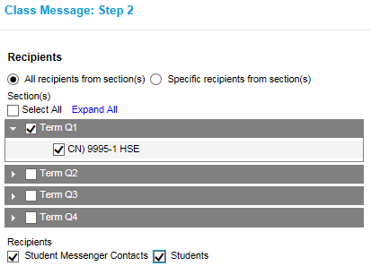
Select the type of recipient and then hit next

Step 4 (all messages)
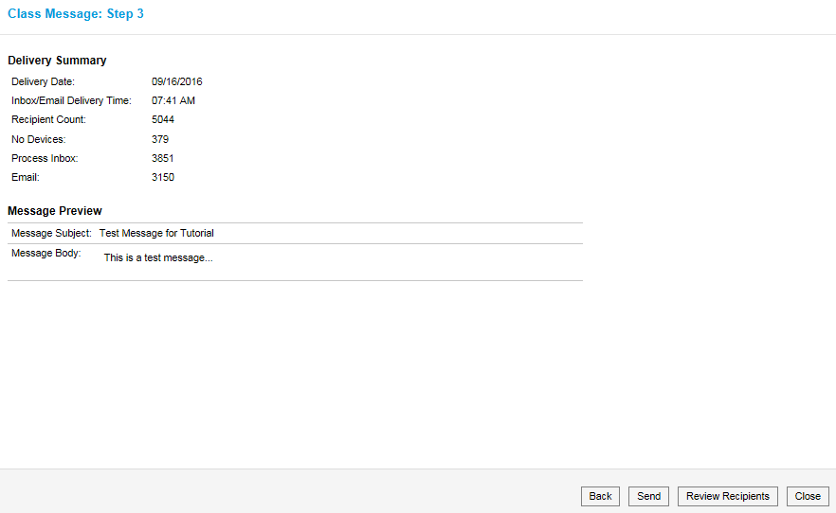
This is the final step
You can review recipients or his send.

Hope this helps!

